|  |
| --- |
| NAMI College(University of Northampton) |
| Report On CSY1018-Assign1 |
| Web Development 1st Assignment |

|  |
| --- |
| Student’s Name: Anish Pithakote  Student ID:16441457  3/8/2017 |

Contents

Design 2

1)INTRODUCTION 2

2

2

2) RESEARCH 3

3) ANALYSIS 6

4) PLANNING 8

5)DESIGNS 9

5.1)SKETCHES 9

a)The Home page 9

b)The CV page 10

c)The BIO page 11

d)The Contact Me page. 12

5.2)The Revised Sketches 12

6)WIREFRAMING 15

(a)THE INDEX PAGE 15

(b)THE BIO (ABOUT ME) PAGE 16

(c) THE FORM PAGE 18

(d) THE C.V PAGE 18

(7) THE RESPONSIVENESS OF THE PAGES 20

8)THE FINAL RESULT 22

a)The Logo 22

b)The Navigation Bar 22

c)The Footer 23

9)THE MOCKUPS 24

10)CONCLUSION 26

11)REFERENCES 26

# 1)INTRODUCTION

The link to my GitHub repository is <https://github.com/crucialzombie/CSY1018-Assign1>

# The assignment assisted us to make a simple personal portfolio website using just HTML5 and CSS.

# It was instructed to insert the students’ names and the their respective UN I.Ds with them as a comment on all codes and files with the assignment folder zipped containing the subfolders like the following as instructed to us:

csy1018-assign1/ All html files (.html)

csy1018-assign1/images All website image files (.gif .jpg)

csy1018-assign1/css All css files (.css)

csy1018-assign1/README.md or README.txt

The author was instructed to deliver four web pages including a homepage, a bio page, a contact page and a “CV” page having the following requirements:

cv page – The cv page should include the name, the education, relevant coursework, professional experience, skills and the activities which are related to my field of study.

contact page – This page should include a form.

Index page – This page should represent the student’s personal home page and should be accessible from the link “GitHub link” of that student.

Bio page: This page should include a short biography of that particular student.

As there are some requirements to be followed and should be included in the web pages, there are some restrictions too. Some of them are as follows:

Tables cannot be used to positioning.

Styling elements in the html code page should not be used.

Inline styles are prohibited.

Absolute URLs cannot be used.

Lorem Ipsum or any kind of filler texts cannot be used.

Frameworks and JavaScript and jQuery cannot be used.

These are some of the requirements and prohibitions which is to be followed by the students.

# 2) RESEARCH

The author knew what he had to do, but he did not have a slightest of idea of how would he start it. He had thought of making a simple website. So, the beginning of the creation of the webpages had to be done by doing some research work. He needed to look at some of the examples or the templates of a simple website. The author did not even have a design so he went online and searched the internet and found some websites which were pretty interesting.

Here are some of the screenshots of the web pages where the author looked up on the internet for ideas them :

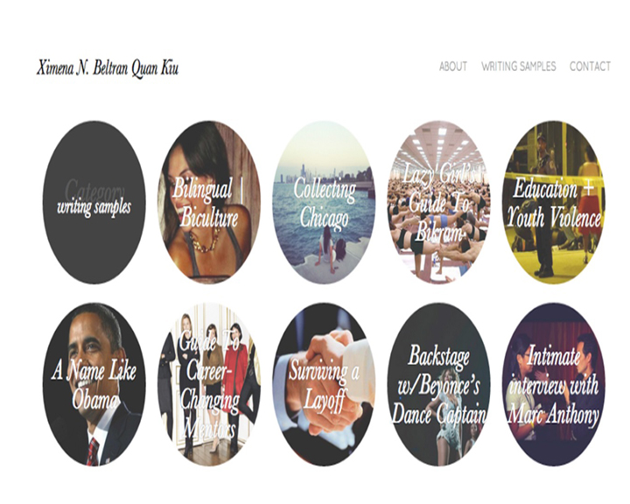

Fig : Screenshot of the webpage made be Ximena N.Beltran Quan Kw

# 

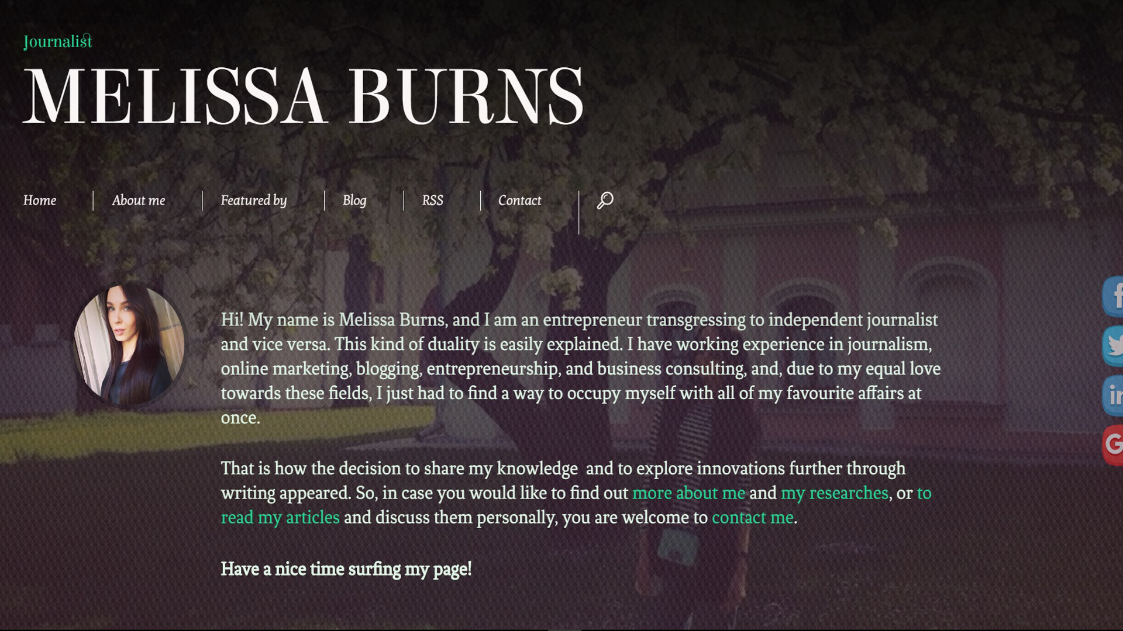

Fig: The screenshot of the webpage made by Melissa Burns.

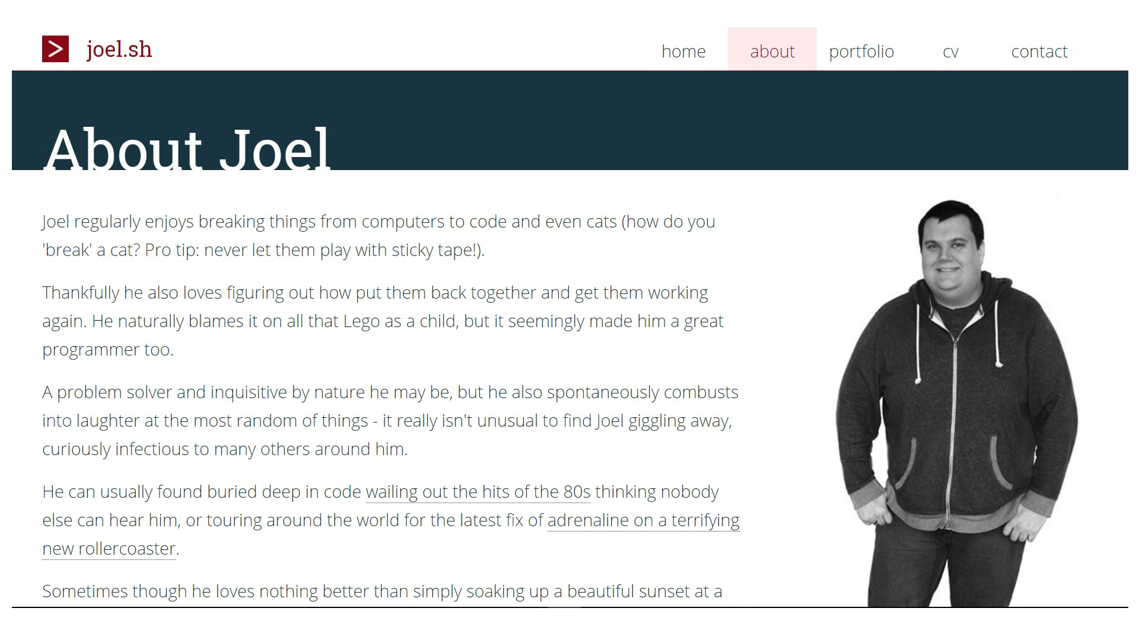

Fig: The screenshot of the webpage of Joel Stanford.

# 

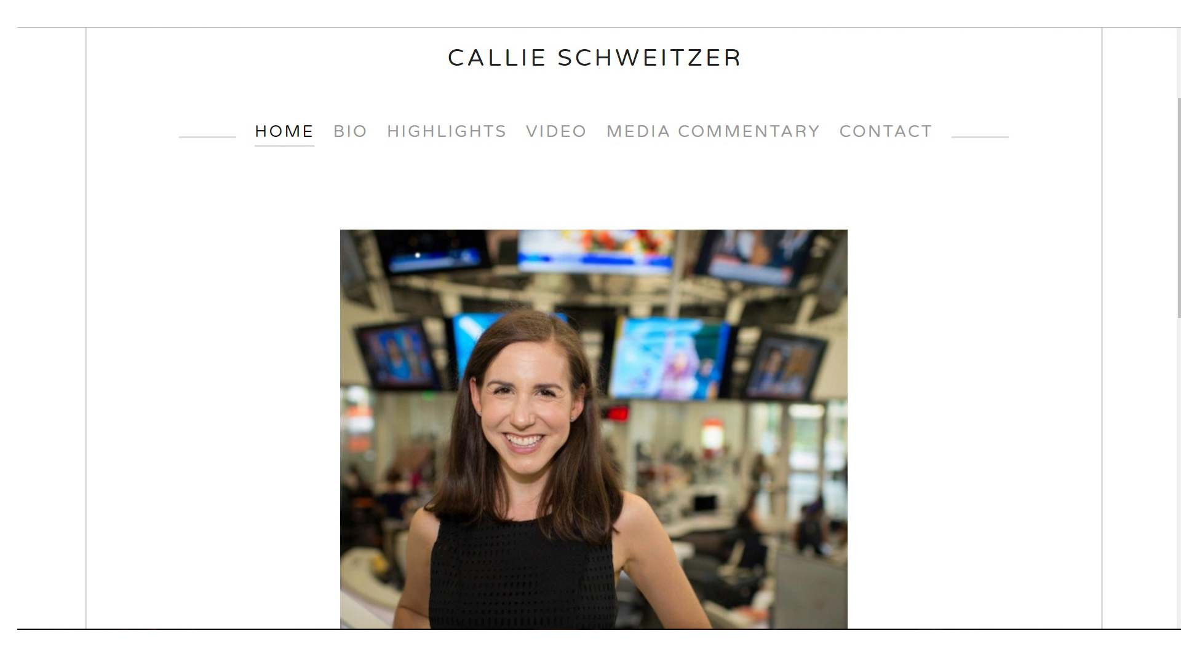

Fig : The screenshot of the webpage made by Callie Schweitzer.

# 3) ANALYSIS

Analyzing, the above webpages that the author visited, have some good ideas and have some really cool features which he really would like to include in his webpages.

All of the pages are quite simple as he wants his webpages would like to be. But there are still some pros and cons of those pages.

Let’s look at the pros and cons of the pages individually.

1. Ximena N.Beltran Quan Kw’s Page:

Pros:

1. The page is quite user friendly as it has a lot of interactive images on it.
2. The page itself is so simple that the user doesn’t find anything confusing or complicated.

Cons:

1. Almost all of the pages look the same.
2. Melissa Burns.’ Page:

This page has got six links linked in it’s webpage. They are home, about me, featured by, blog, rss and contact.

Pros:

1. The page is quite easy to navigate around.
2. The page is simple design.
3. Cool looking JavaScript have been used making the webpage attractive.

CONS:

1. The fonts used are not so user friendly as it makes the website a little weird looking and makes it lose its charm.
2. There is too much gap between the navigation bar and the main content making look a little out of place.
3. When clicked on “featured by” button, nine company logos appear which are linked to their respective websites.

These logos are kept do close to each other with nothing to specify each logo’s border which makes the user difficult to see where they have clicked.

These logos are not assembled in quite a pleasing look.

1. Different fonts of different sizes have been used in multiple sections of the webpages.

It makes the webpage look kind of un pleasing to look at and the user might feel something has changed and has made the webpage not good but they cannot figure out exactly what that is.

1. RSS page look as if every piece of information has been put in a small box without assembling those information making it look ugly.
2. Joel Stanford’s Page:

Pros:

1. The webpage is user friendly.
2. Very easy to navigate.
3. Interactive buttons.
4. The smooth movement of fixed navigation bar makes the impression of the website even better.
5. The color combination of the webpage is quite pleasing and has fitted perfectly to the page.
6. The map feature has been added to the bottom of the page making it a little bit attractive and making the user find out where he os at the moment .

Cons:

1. Only little part of the information is provided about Joel.
2. The logo is very attractive but he should have made it linked to the home page which is not done.
3. The footer has quite congested with all the items mashed together.
4. Callie Schweitzer’s Page:

Pros:

1. When the page’s window is shrunk down, the navigation bar disappears and instead of that, a “MENU” appears which on clicked shows the navigation bar items aligned in a column.
2. The page looks clean because of the color choice as there is not much color used. The only color used is white for the background and black for the font.
3. User friendly hover properties have been used which makes easy for the user to select the particular button.

CONS:

1. The one thing I didn’t like at the first when I saw the page was the font type, and the adjustment of the font contents. They have not been arranged in a way that would make the page attractive but creates a type of “Ugliness” in the page.
2. The spacing between the contents and the outer line and the screen is too much making it seem like too much of space is left out.
3. The content in the “Contact” page could have been arranged in a way more adjustable way rather than making it seem like they have been mashed up together.

# PLANNING

As per the research done and seen on the already published websites he pointed out some of the pros and cons of each of those web pages. He then carefully studied the designs of those web pages and came to a conclusion of making a website of this type of layout:

# 5)DESIGNS

## 5.1)SKETCHES

Before making any wireframes and making the final decision about the looks of the website, the author had to brainstorm the ideas he had and had to present the ideas in the paper through the means of sketches. First he came up with the ideas of the following sketches.

### a)The Home page

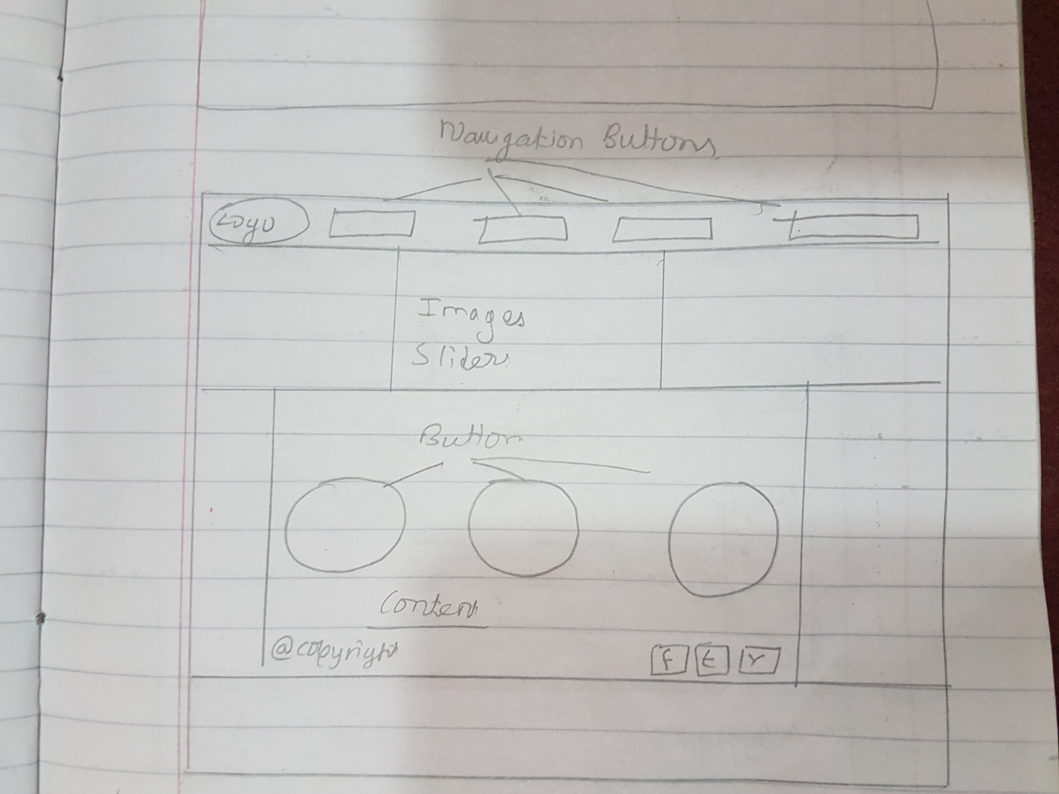

Sketch1: The home page

The home page sketch was included with the navigation bar on the top, the footer in the bottom, an image slider and the main interactive buttons in the body part.

The links to the social medias were given on the right side of the footer.

### b)The CV page

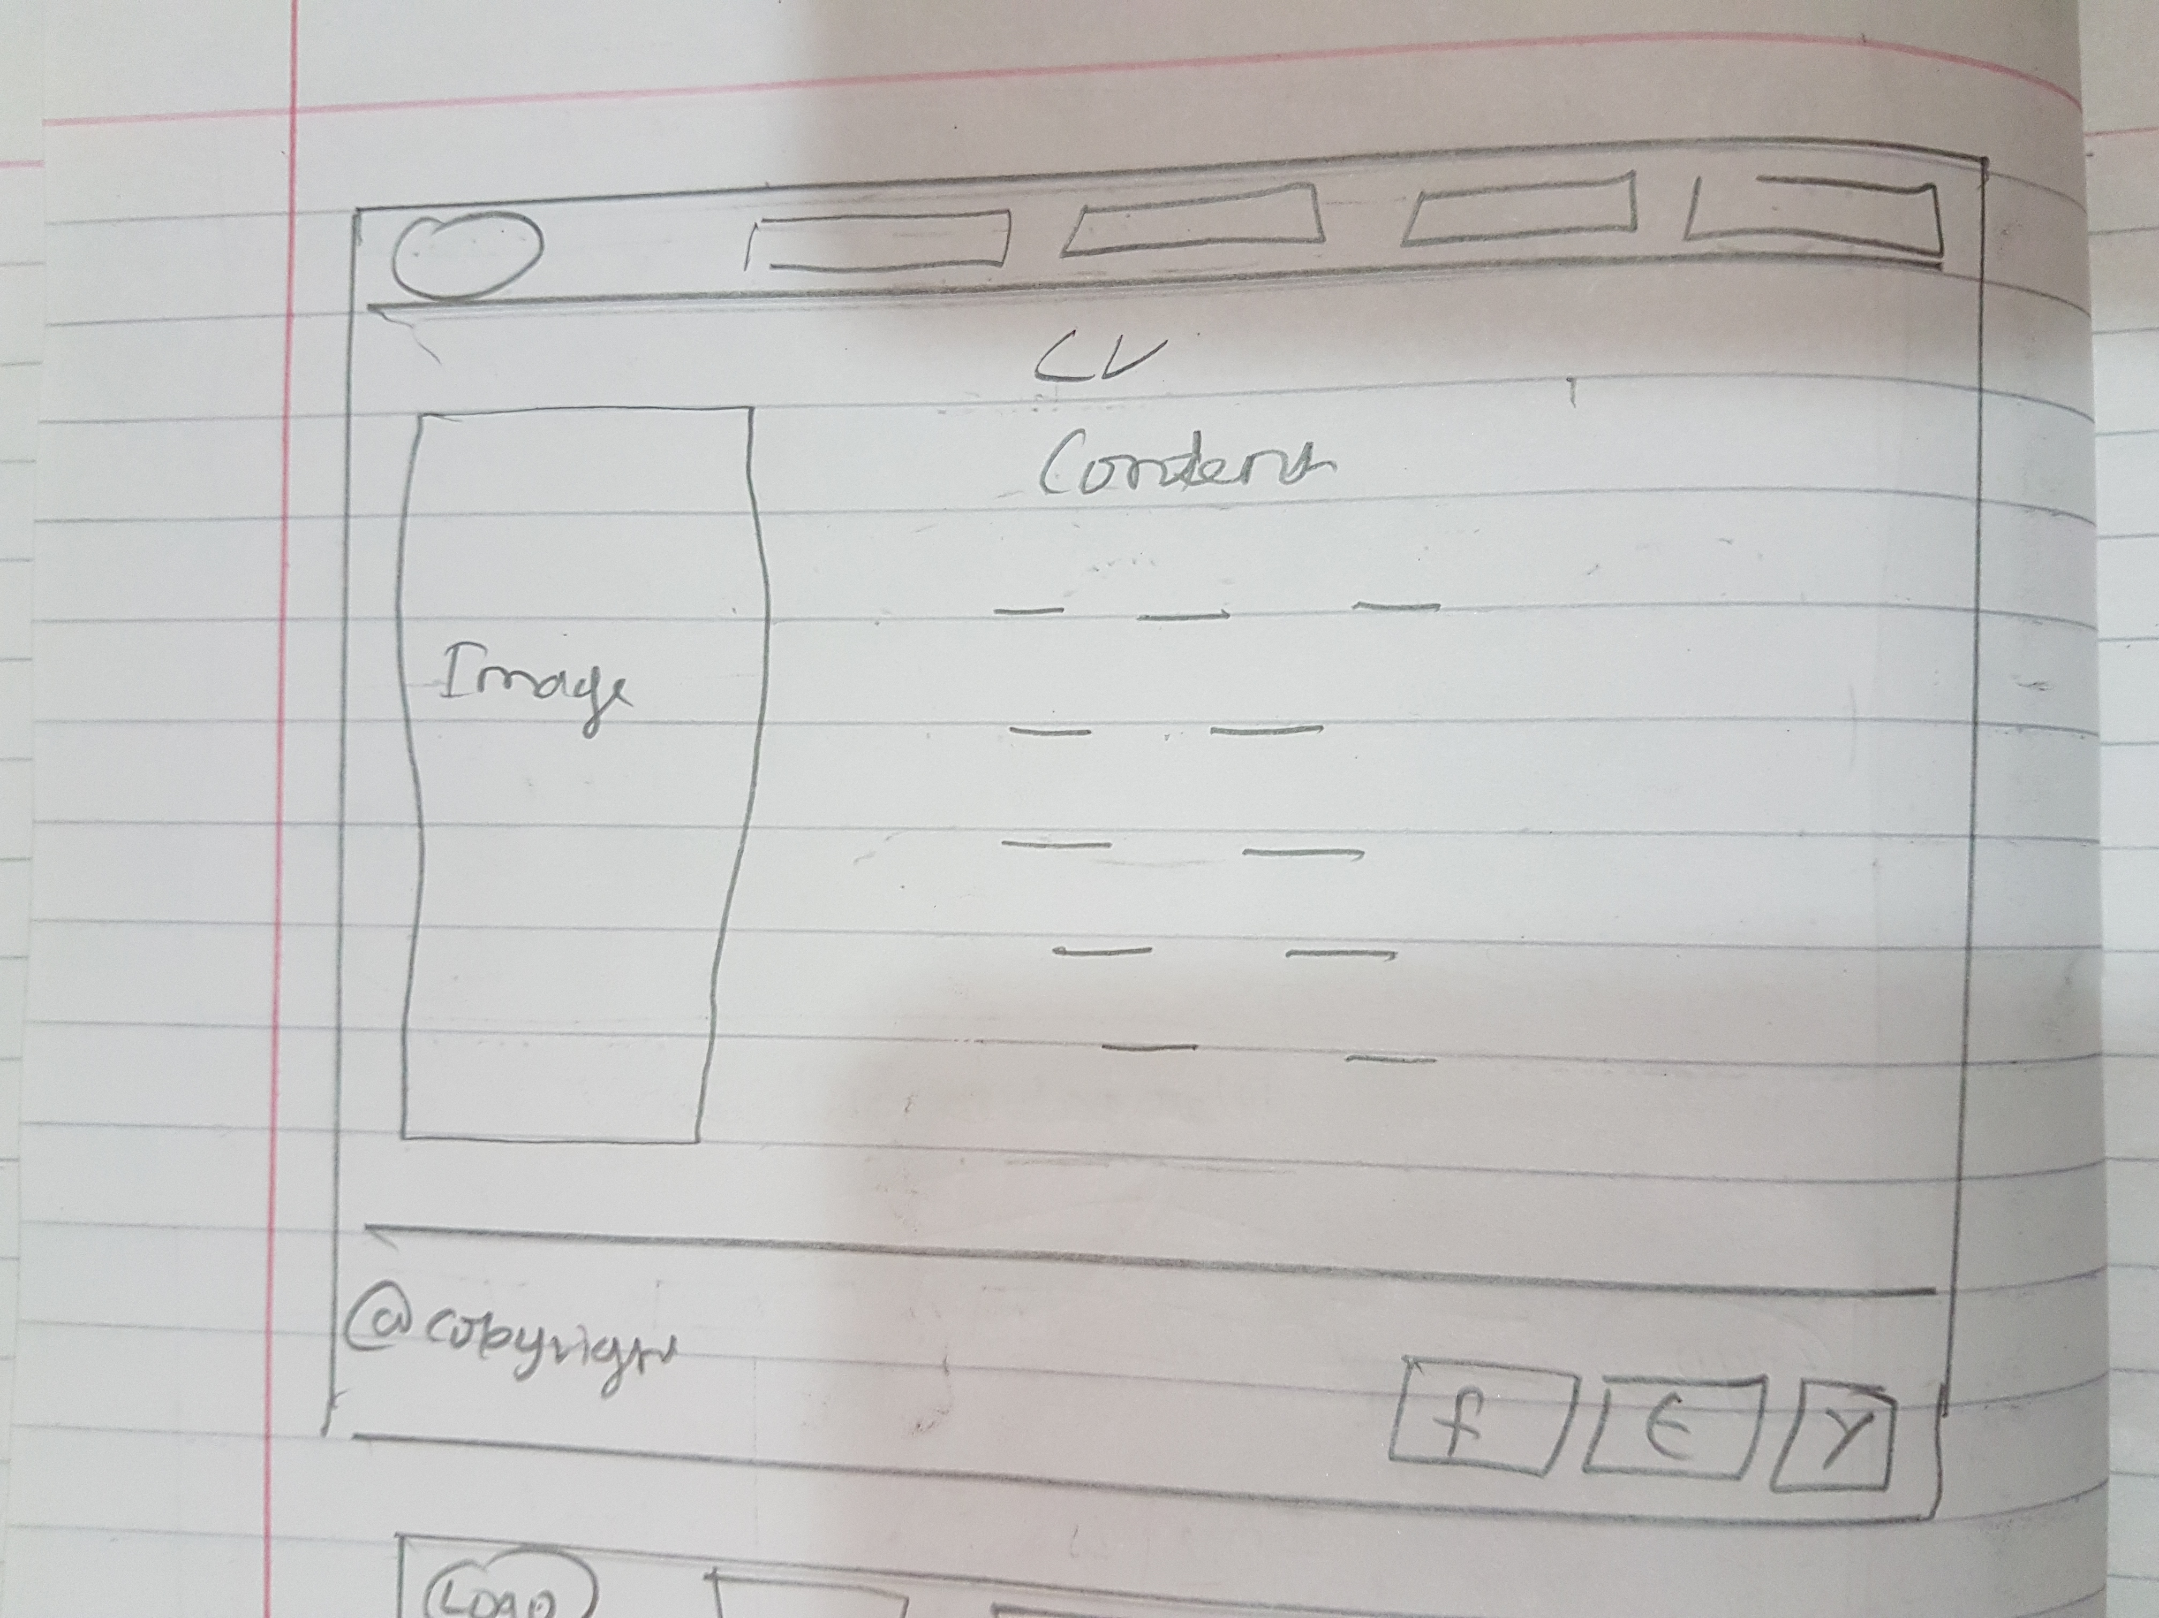

Sketch2: The CV sketch.

An image section was put on the left side of the page with the contents in the right side of the page.

### c)The BIO page

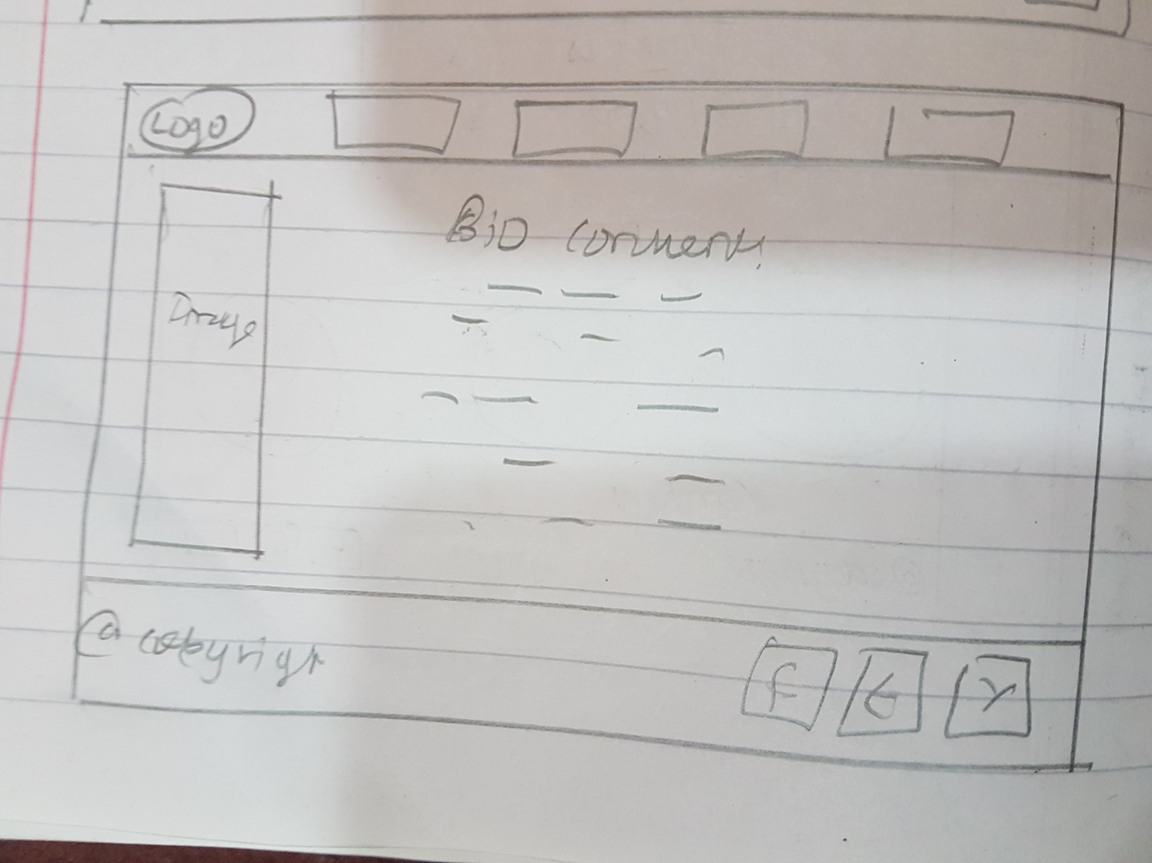

Sketch3: The bio page sketch.

The bio page had the same image section as the CV page but with different image and with bio contents on the right side of the image.

### d)The Contact Me page.

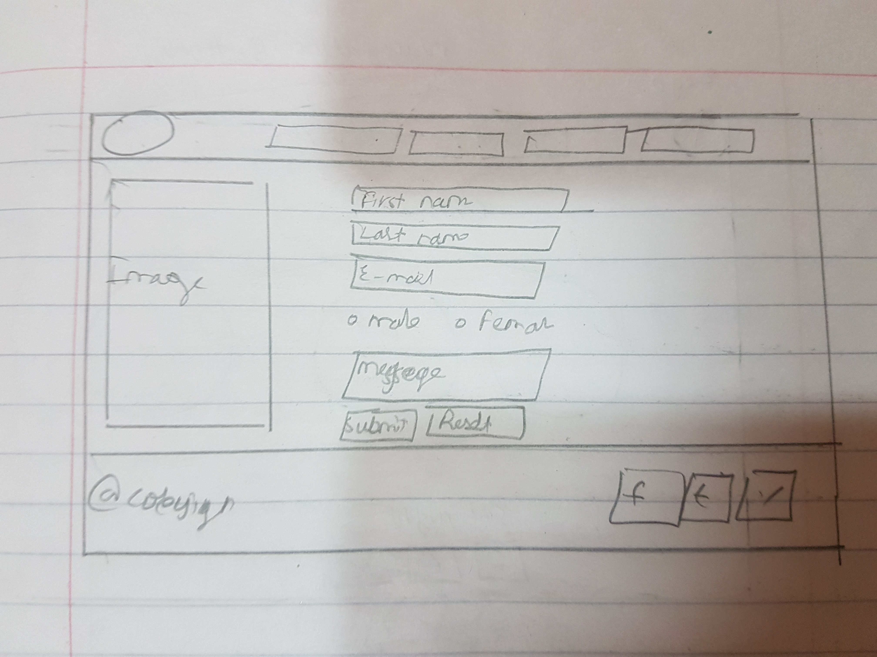

Sketch 4: The contact me page.

This sketch also had a section for the image on the left side of the sketch, with the contact me form of the right side.

## 5.2) The Revised Sketches

The sketches were remade because the author didn’t feel content about the sketches he had made while brainstorming and when the author visualized the sketches in the terms of real life website, because of “too much contents,” the website looked kind of messed up and looked as if some things were put there without any organizing of the contents.

So here are the final sketches the author has made.

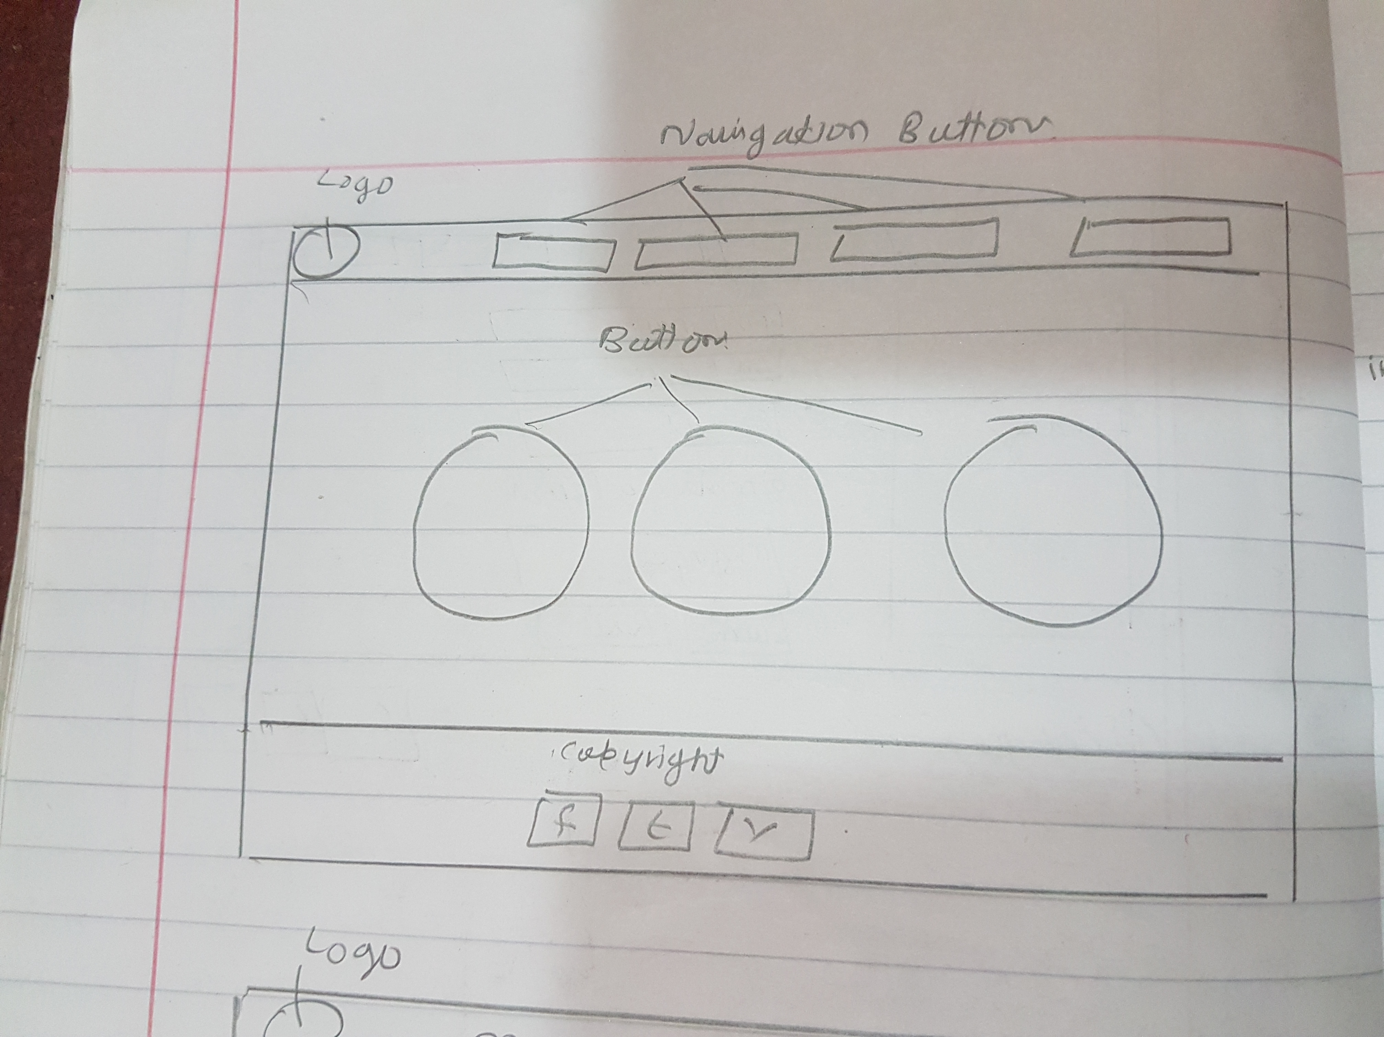

Sketch5: The revised home page sketch.

Not much changes are made , but the image slider has been removed to give it a simple look and the copyright and the social media buttons , which were placed on the left side and the right side of the footer are now placed in the center on top of each other.

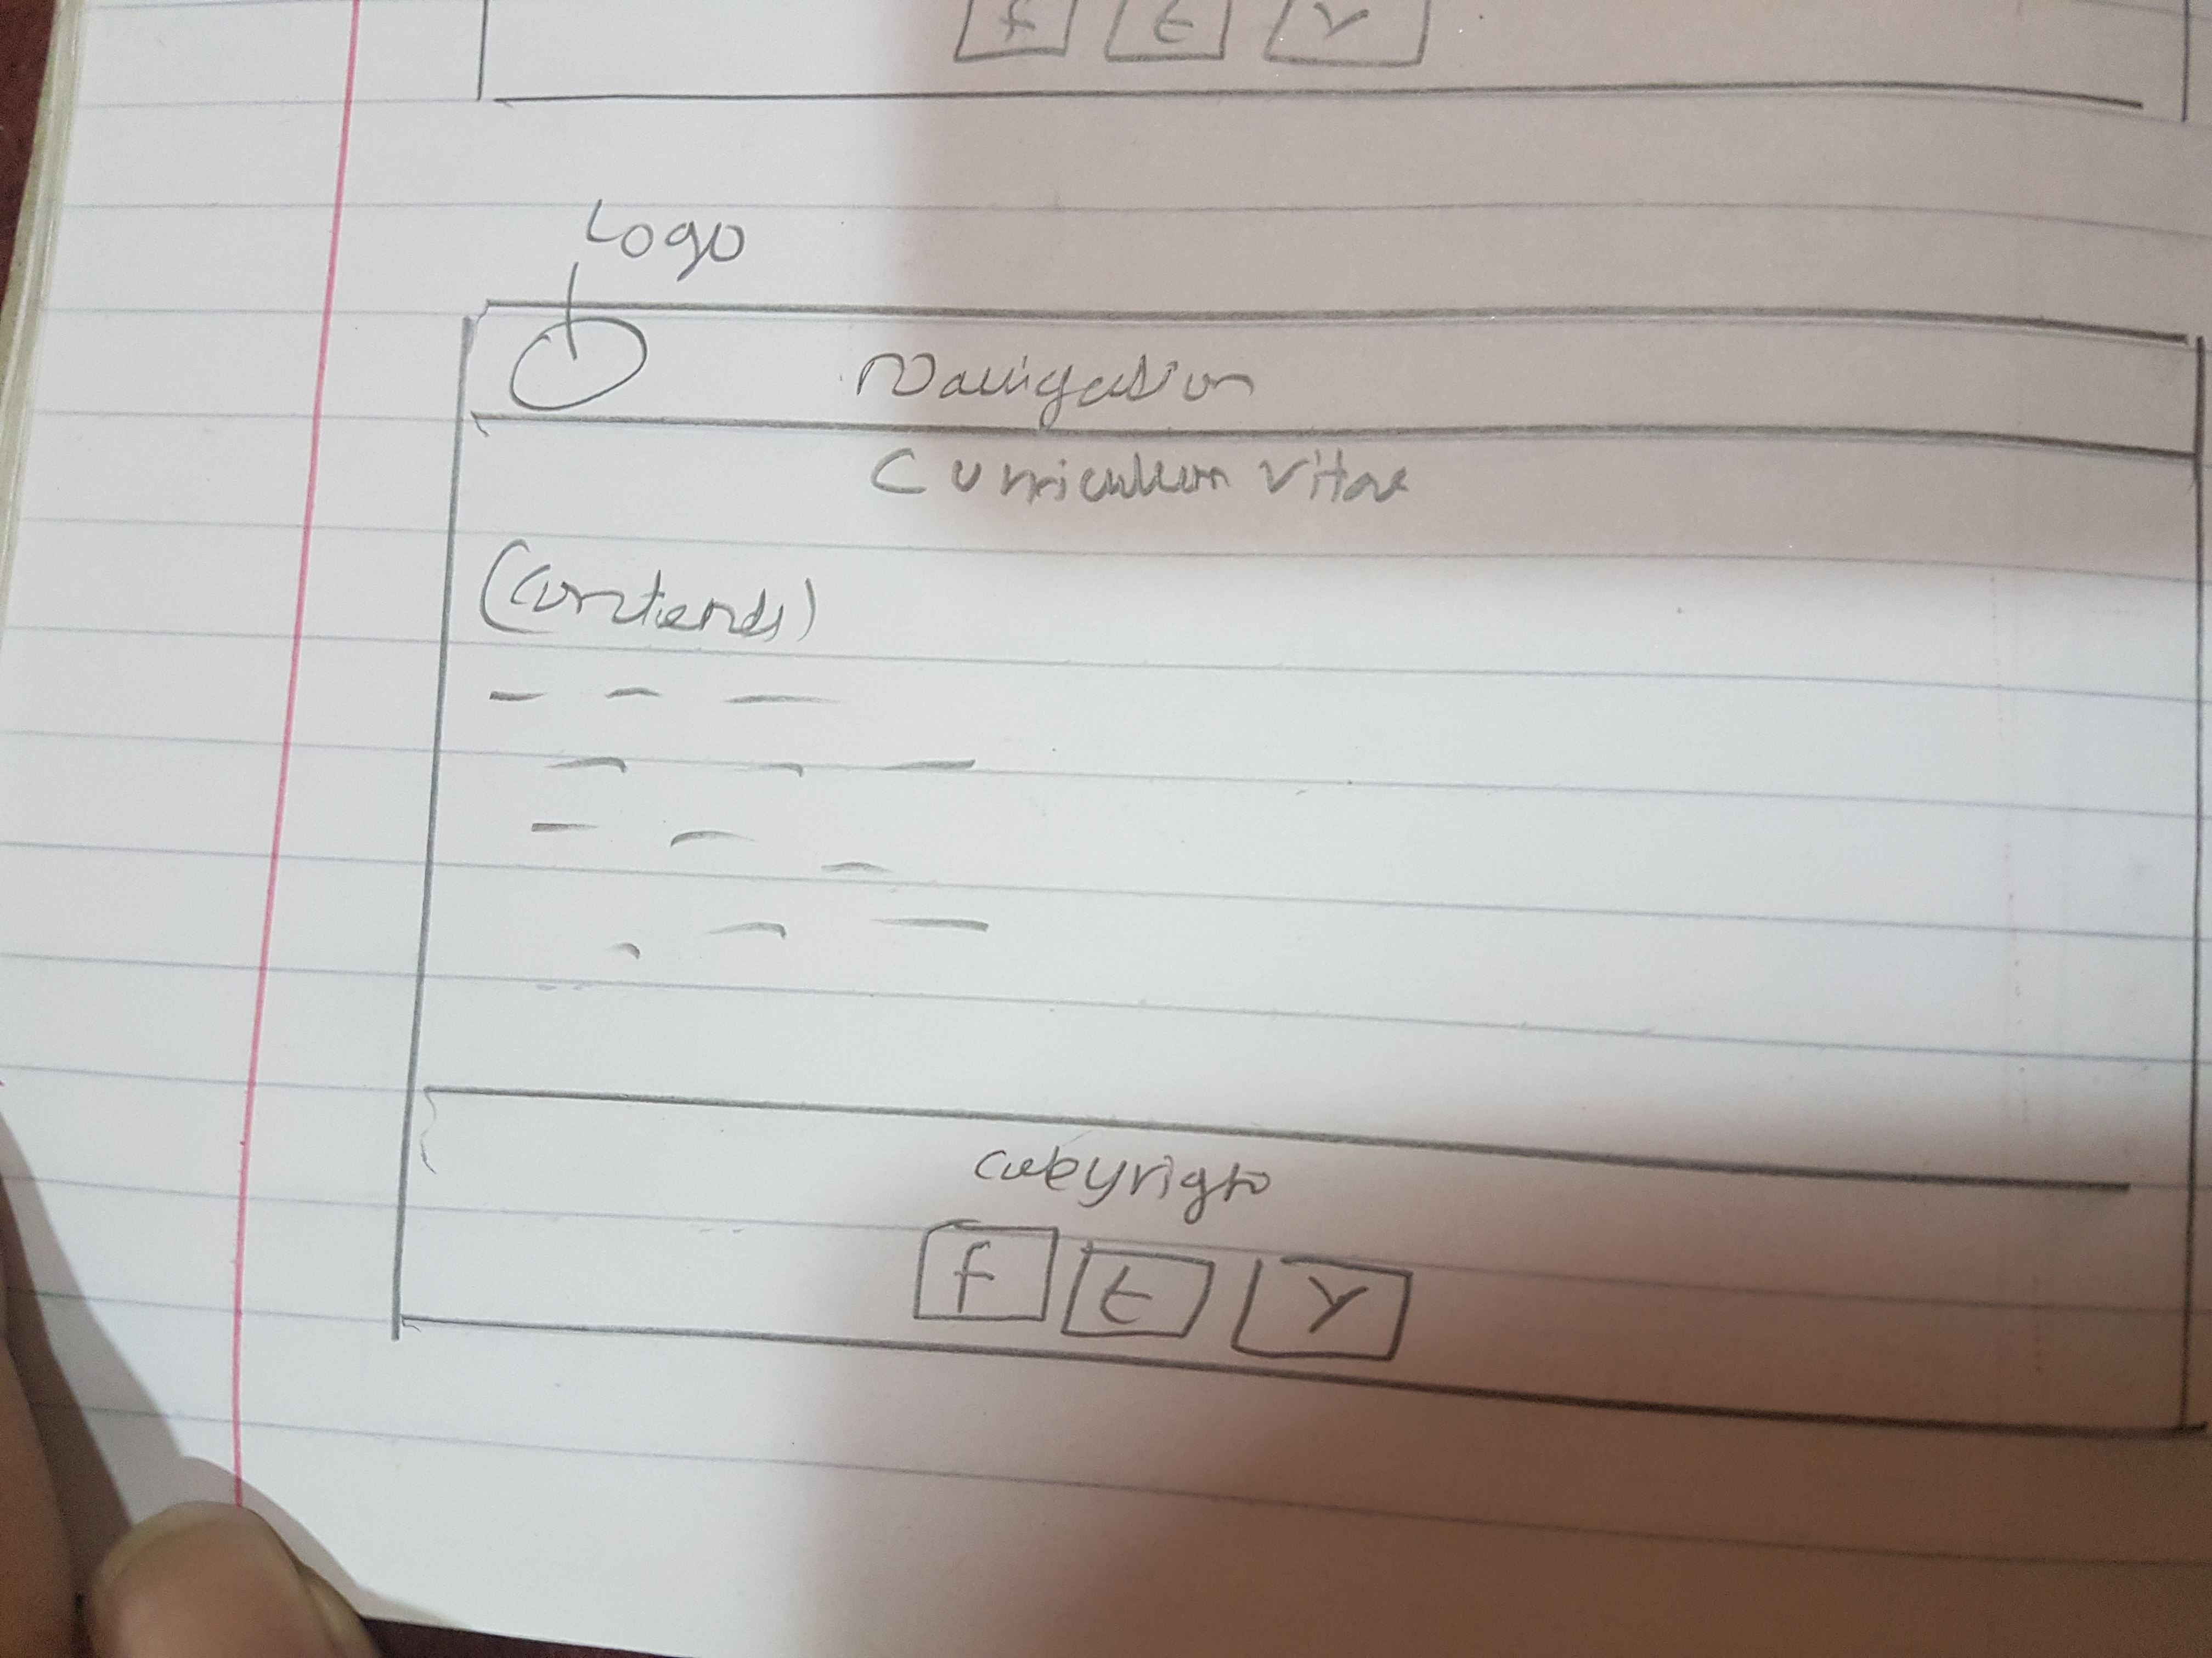

Sketch6: The revised CV page.

The image section which was present on the previous sketch has been removed and only the contents are now in place.

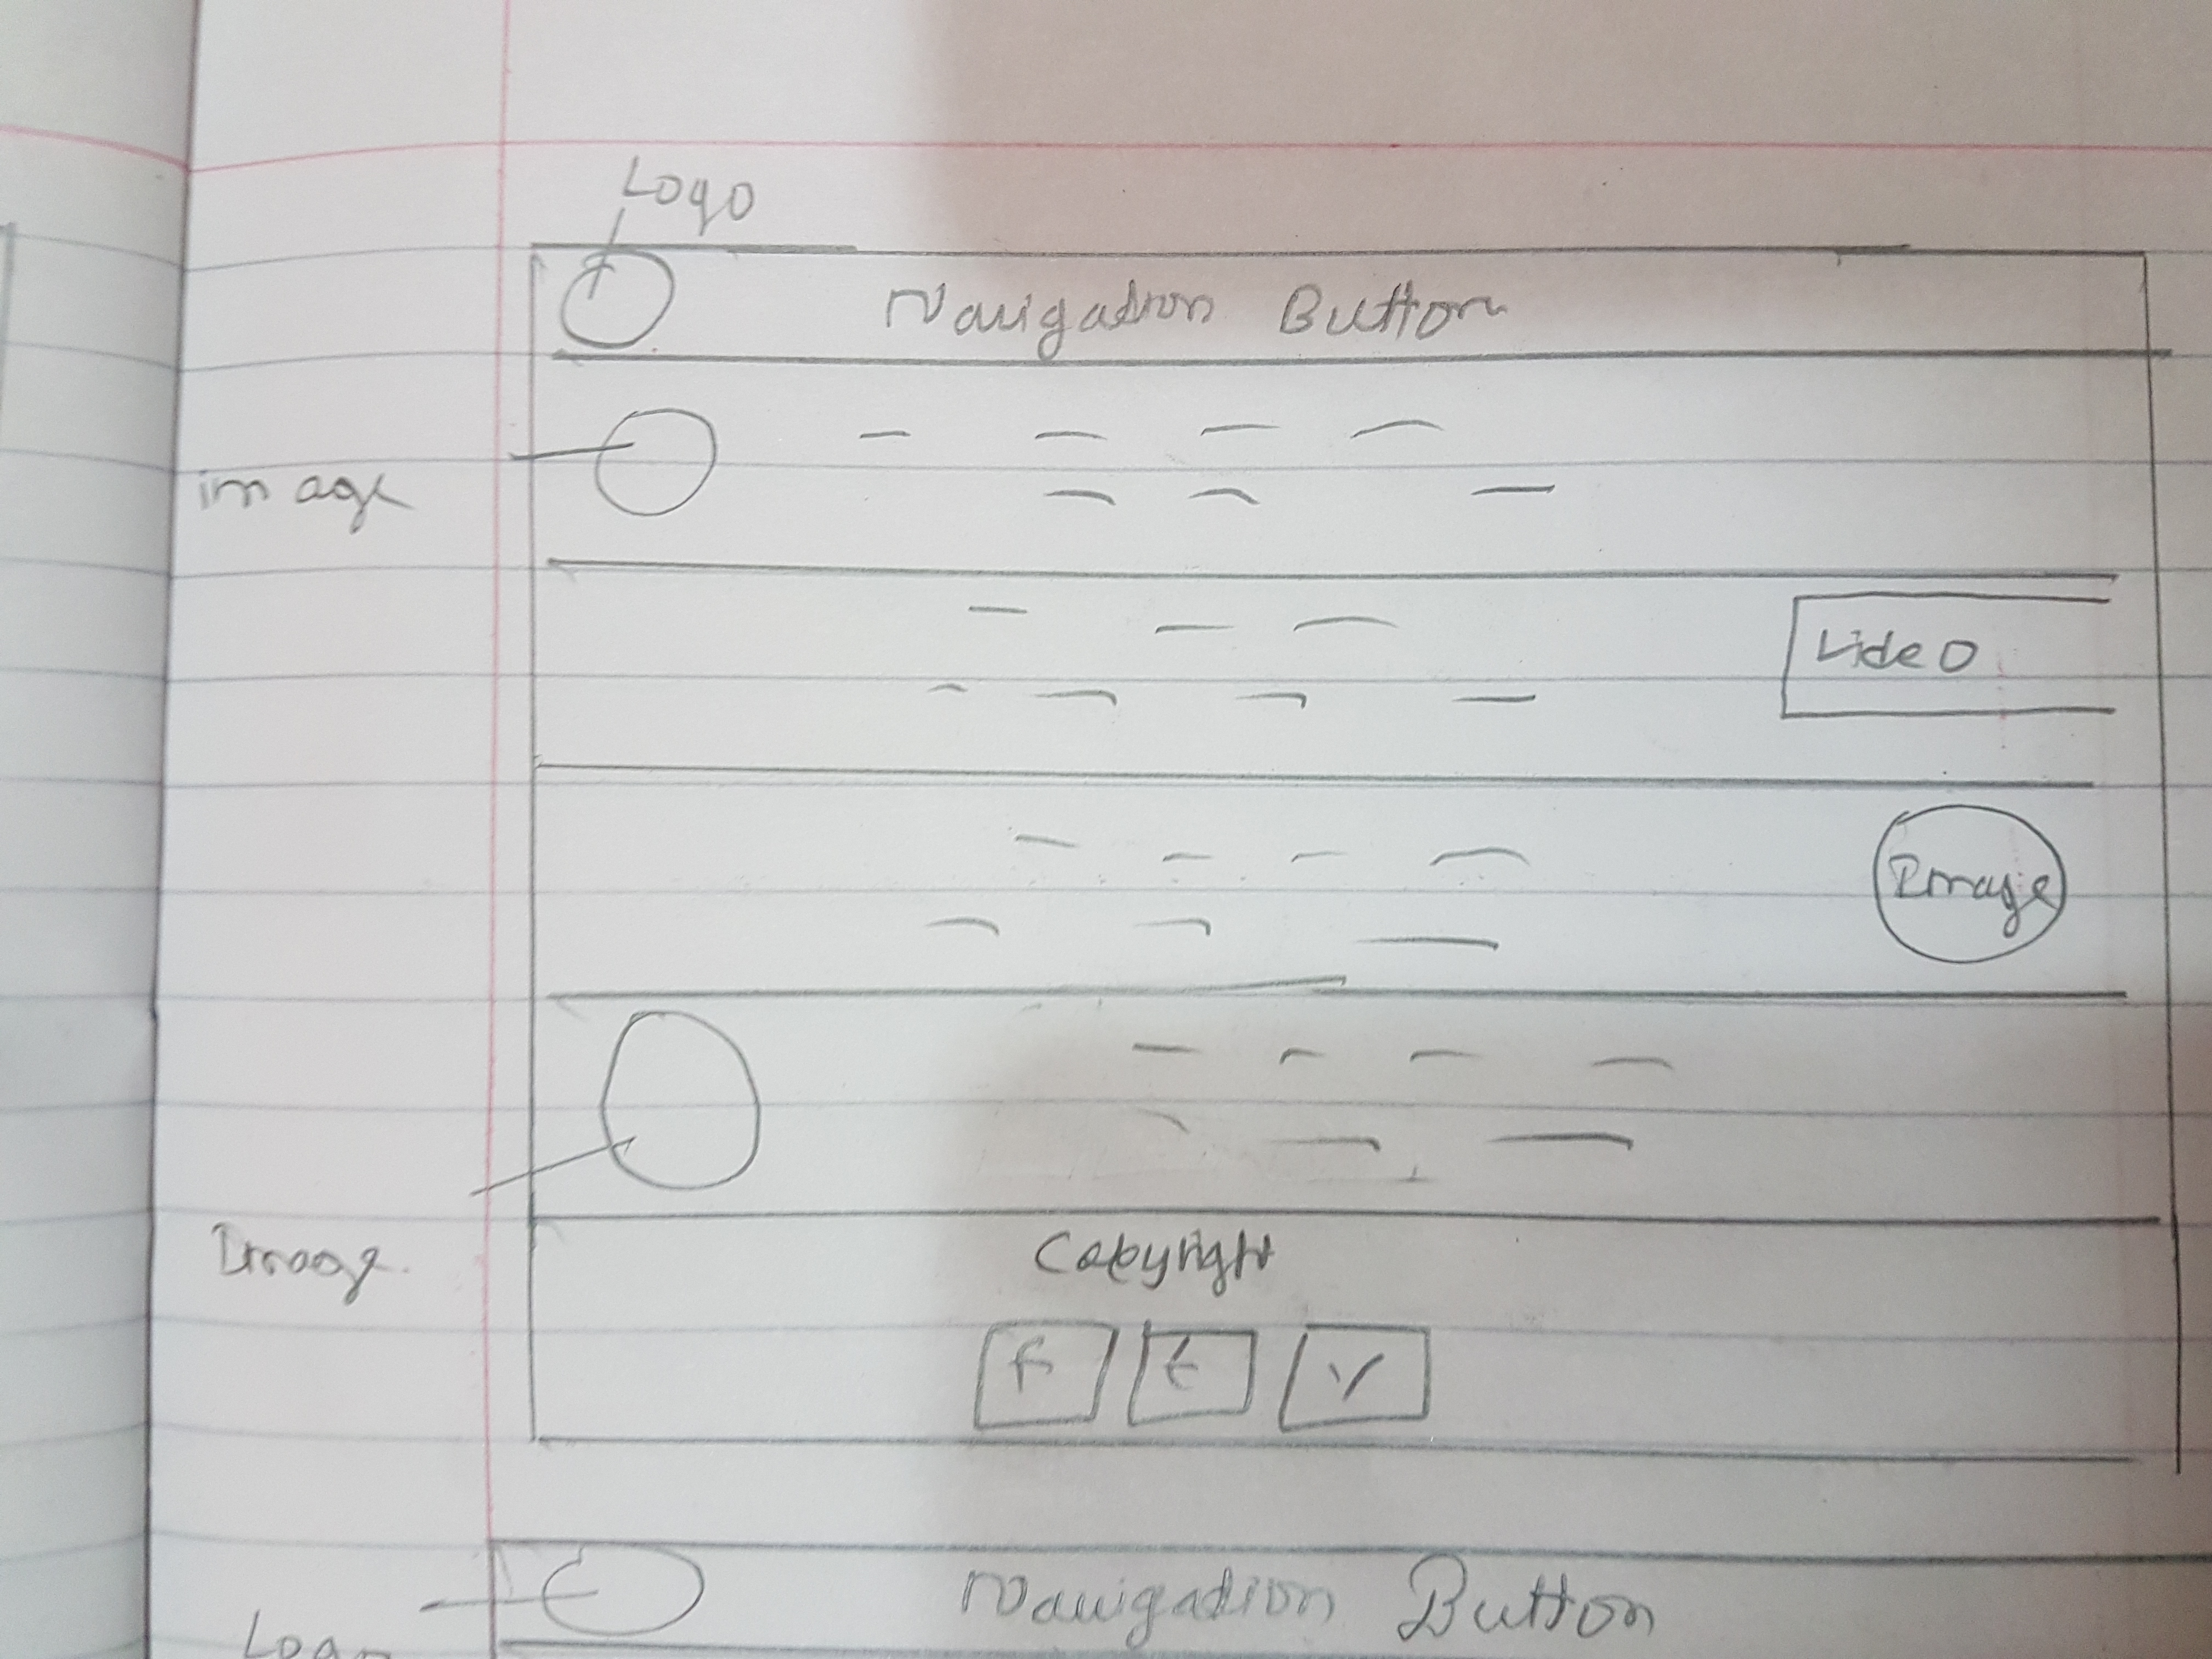

Sketch7: The revised sketch of the BIO page.

The contents of the bio page have changed totally, as the previous sketch had an image on the side and all the information on the other. But now in this new sketch, multiple images are included with a video, and they are separated along with their contents.

# 6)WIREFRAMING

After the final sketches were put in palace, the wireframes were made.

## (a)THE INDEX PAGE

Started to create index page for the assignment.

The author has decided to make my index page according to the following index wireframe.

I

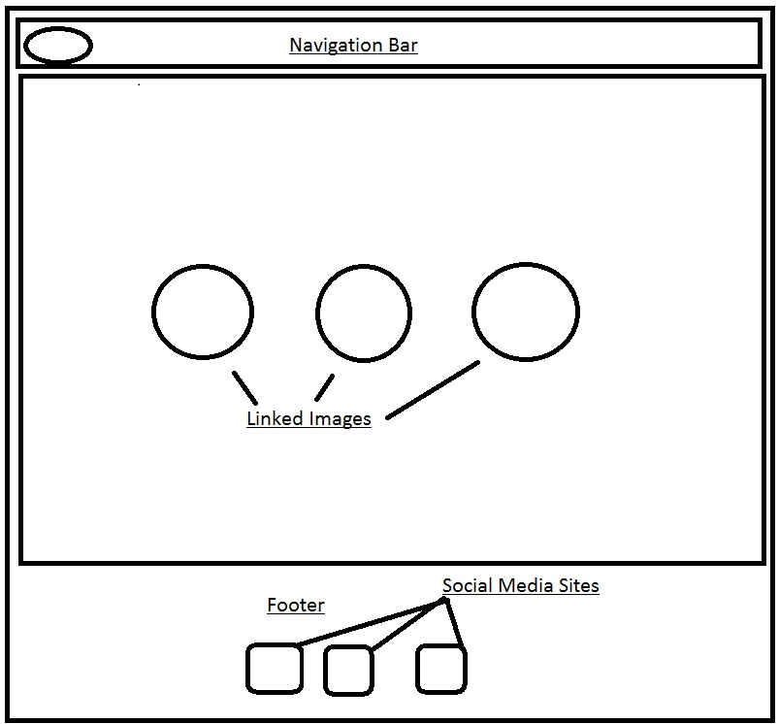

Fig(1): Wireframe for the index page.

Navigation Bar: This bar will contain Home, CV, Contact Me and About Me buttons linking to their respective pages.

Logo: My custom built logo will be placed there.

Images in Ovals: Pictures will be kept with a line describing them and linking to their respective pages.

Footer: The footer section will contain the links to my social media sites.

The web designing codes are also accompanied with their respective comments.

## (b)THE BIO (ABOUT ME) PAGE

The bio section consists of a navigation bar, a wrapper and a footer at the bottom.

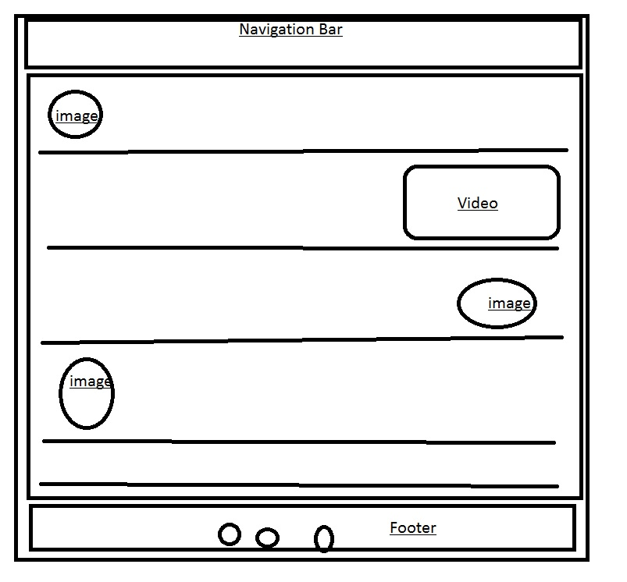

Fig(2): The basic wire framing of the Bio page.

The Navigation Bar: It consists of links to Index, CV, Bio and form pages. And a logo on the left side.

The Body (wrapper): It consists of the main content, where I have written all of my life’s details from my passions, hobbies and likes.

It has been further divided into five parts where first part tells about my bio in a brief version.  
from the second part, more contents like fitness, dancing and animals have been put up with their respective images and a video.

The footer: Consisting of icons linking to my social media sites.

After the designing of the bio page, I started working on the form page.

## (c) THE FORM PAGE

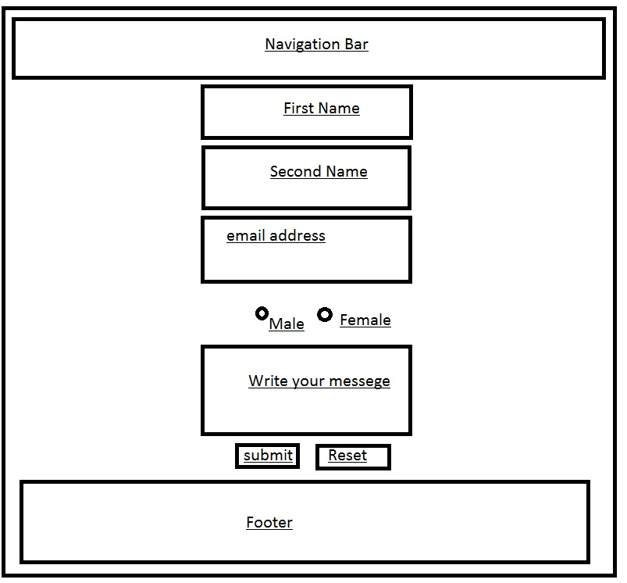

Fig(3):The basic wire framing of the form page.

The Navigation Bar: This bar consists of buttons linking to their respective pages.

The body (wrapper): This part consists of boxes, telling the people who are trying to contact me to enter

Their first name, last name, their email address, their gender and their message.

They can click on submit to send that message or if they want to erase everything they have written, the they can press the “reset” button.

After one and a half day of finishing three of my pages i.e. index, bio and form.html pages, He made this page responsive and changed the flex direction in to columns from rows.

## (d) THE C.V PAGE

This page was made at the last i.e. I made this page when he was done with the previous three pages. (index.html, bio.html, form.html).

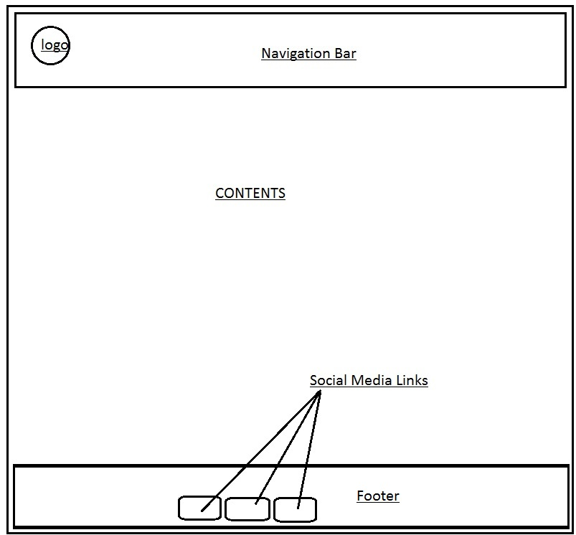

Fig (4): The wireframe of the CV.html page.

The Navigation Bar: In this section, there are Home, CV, About Me and Contact Me buttons which are respectively linked to their pages.

Logo: This section has a custom built logo which will be linked to the homepage.

Footer: The footer contains the Images of the social media sites which are linked to my social profiles

Contents: The contents contains the information about my experiences and skills.

(7) THE RESPONSIVENESS OF THE PAGES 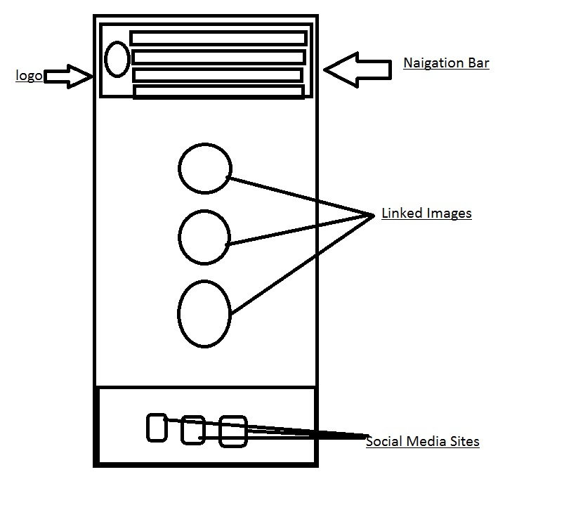 Fig(1.1)The Index page when the browser size is resized to 600px.

After a week of designing three of the pages,,  
The author decided to make the index.html page responsive. The fields where the flex directions were set to “row” will now change to flex direction “column” when the window will shrink to 600px size.

The navigation bar, the pictures in the class “wrapper” will all align in a column.

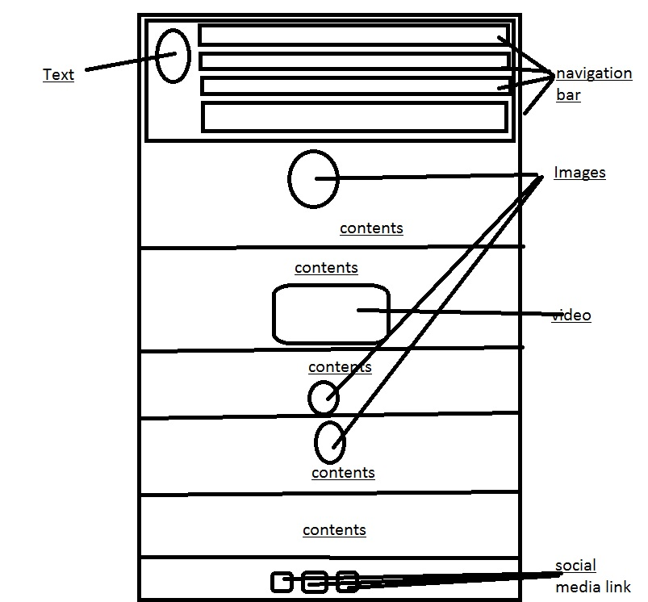

Fig (2.1) The responsive wireframe of the bio page.

The webpage was made responsive by using the “@media queries” and customizing the css file again under that condition.

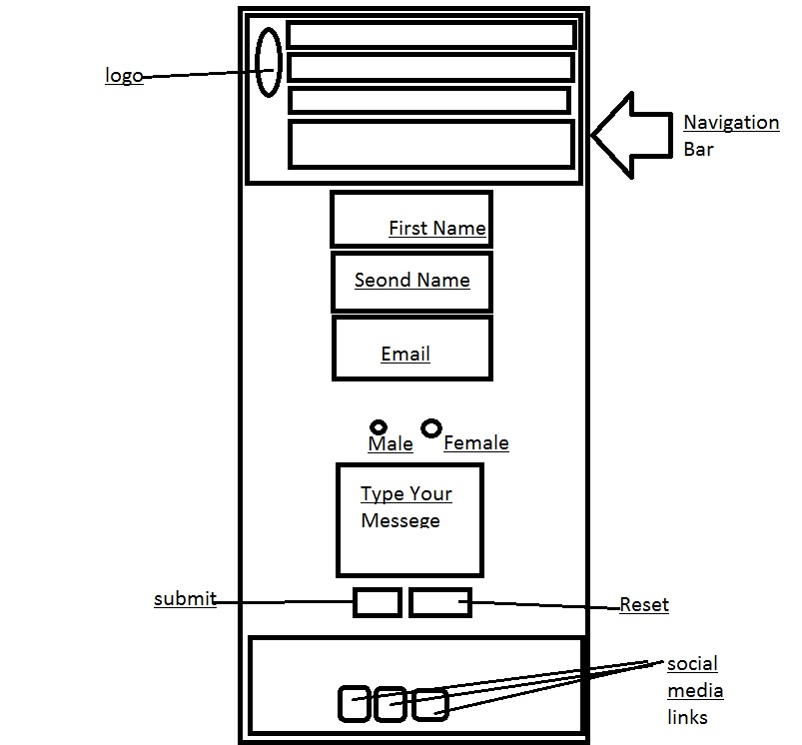

Fig(3.1):The responsie form.html page

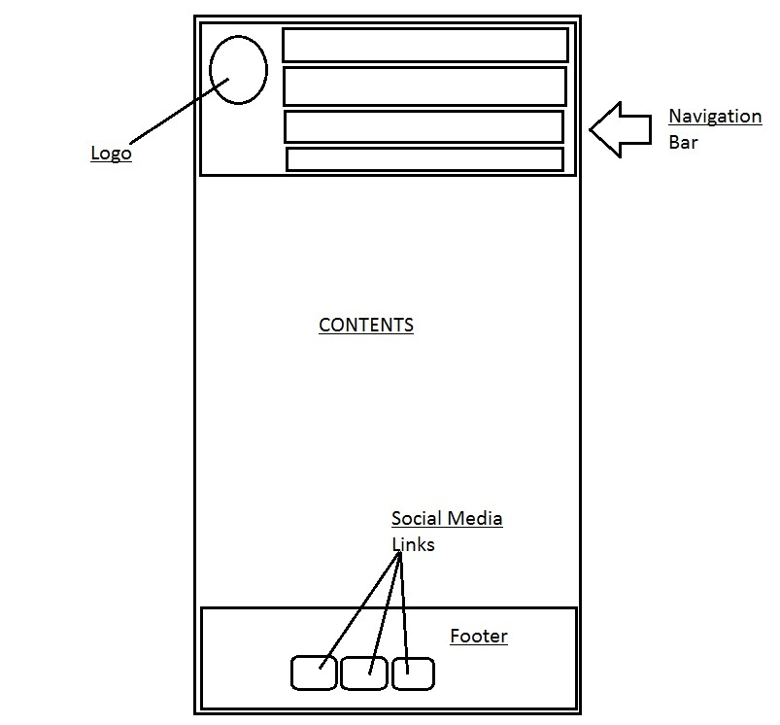

Fig(4.1): The responsive webpage of the CV.html

# 8)THE FINAL RESULT

## a)The Logo



Fig: The logo of the page

This is a custom built logo used in this project. The logo will appear in all of the webpages on the top left corner of each page and when a user clicks of the logo, it will lead them to the main home page.

b)The Navigation Bar

Fig: The Navigation Bar Menu

This menu will be present in each of the pages in the website and through it, the users can navigate around the website by selecting which page would they like to visit.

The Navigation bar consists of Home, CV, About Me and Contact Me buttons which will guide the user to the home page, the CV page, the bio page and the contact me page respectively when clicked on.

## c)The Footer



Fig:The footer part.

This footer part consists of the social media(facebook, twitter and Youtube) sites where the user can contact me throught the social media if they wish to do so.

Every webpages have been assigned with google api fonts too.

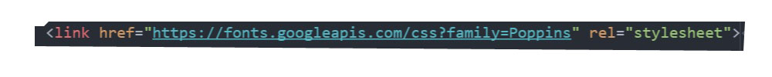

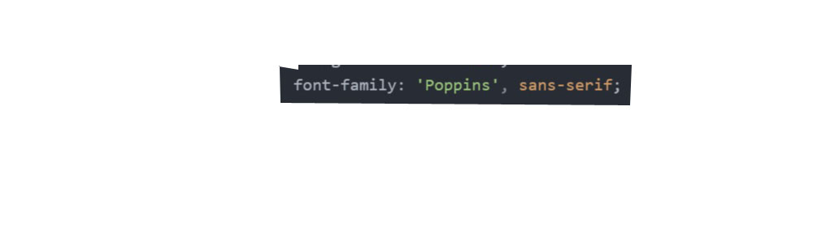

Fig: Links in the html file and the css showing the use of google api fonts

# 9)THE MOCKUPS

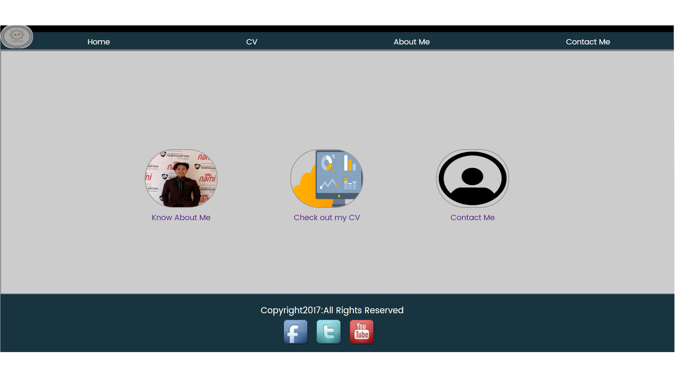

Fig:The final index page.

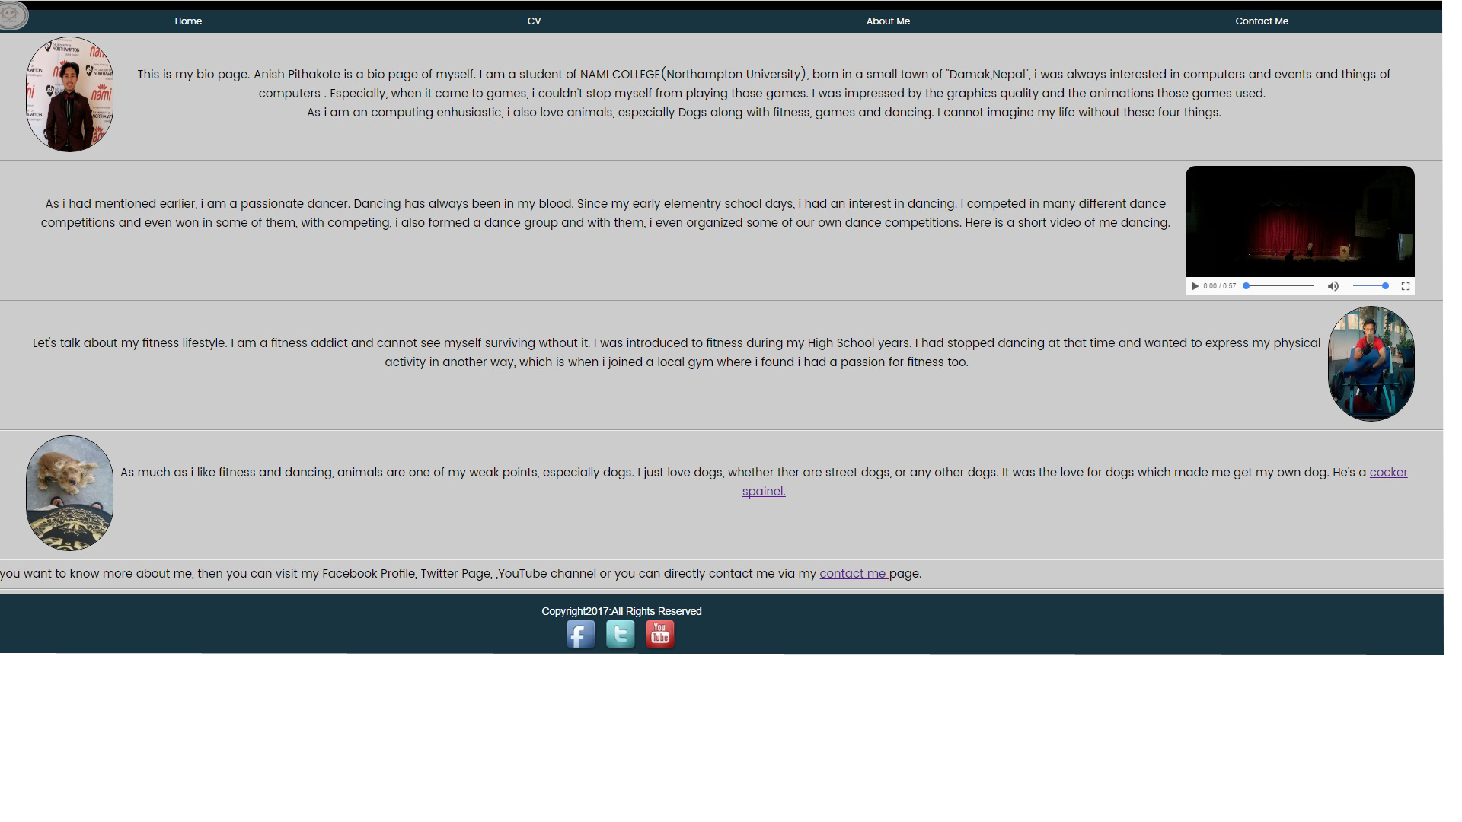

Fig: The final about me(bio) page

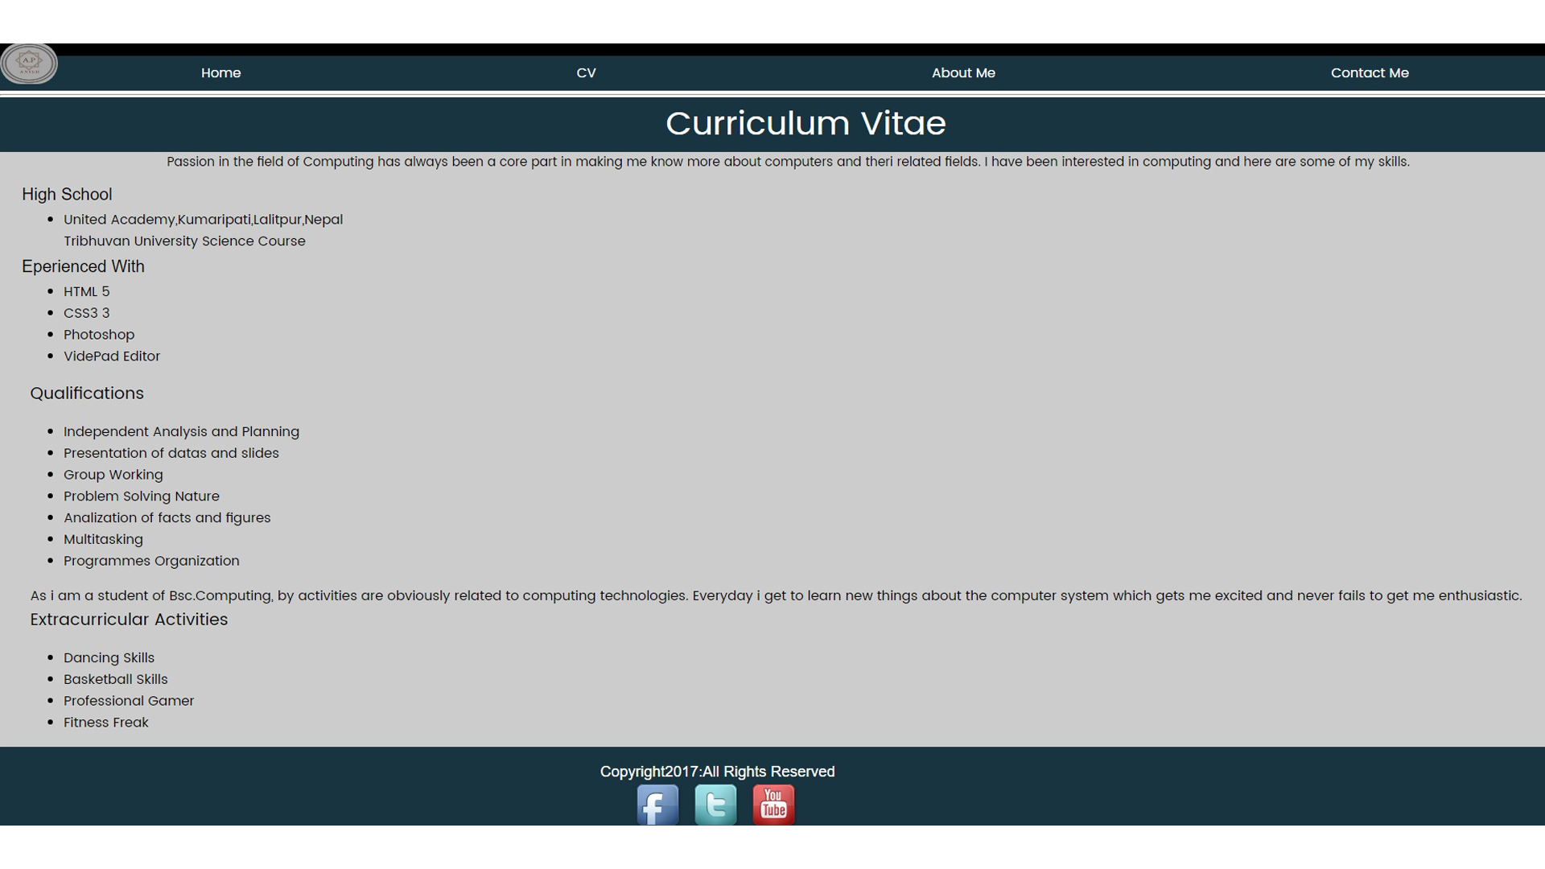

Fig: The final CV page.

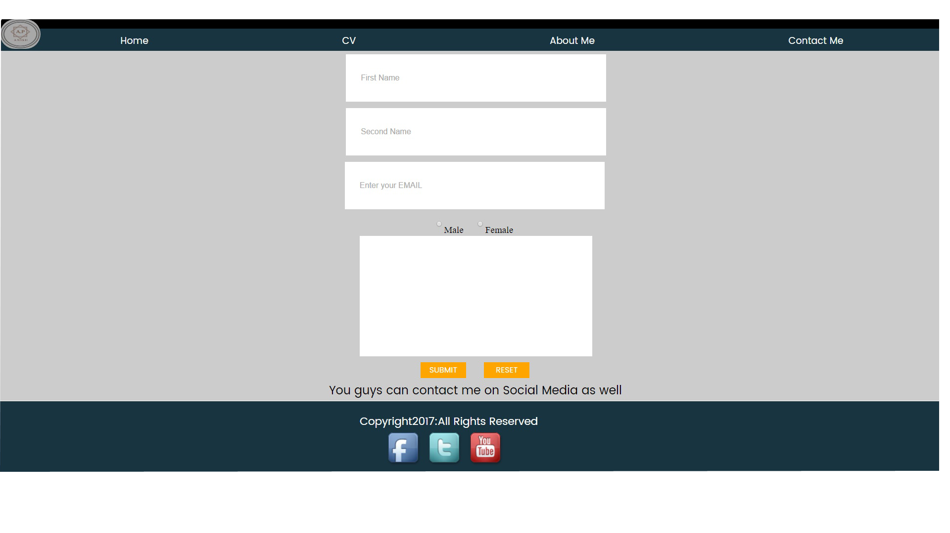

Fig: The final Contact Me(form) page.

# 10)CONCLUSION

Each of the webpages were designed at least for 3 to 4 hours per day. Each of the pages were finished designing at the 3rd to the 4th day, i.e. each webpage took 3 to 4 days to finish. So approximately the author spend nearly 64-90 hours just on designing, making them , and revising the sketches and again making the webpages.  
After the author had finished designing the webpages, then he wanted to make them responsive. So, he added “@media “to make the pages responsive if the browser window was to be shrunk to the size of 600px.

Once the browsers would be shrunk, the contents placed in the row, will appear to be in a column form. He completed making the pages responsive in 1 day working for 1 hour.

# 11)REFERENCES

1. Stanford,J.(2015)Joel.sh.*NileNorthampton*[Online]. Available from:https://joel.sh [Accessed 1st March 2017].
2. Edmund, K. (2014) Beautiful web design is my passion. *Kelly Edmunds*[Online]. Available from: Kellyedmunds.co.uk [Accessed 10th March 2017].
3. Scherf, R. (2017) Ryan Scherf Designer X Maker. [Online]. Available from: ryanscherf.net [Accessed 11th March 2017].
4. Schweitzer, C. (2015) Callie Schweitzer [Online]. Available from: www.callieschweitzer.com [Accessed 15th March 2017].
5. Burns, M. (2016) Melissa Burns. *Google*[Online]. Available from: www.melissaburns.me [Accessed 15th March 2017].

Rleonard.com/interactive-resume

Errors like using backslash for path segment delimiter, stray tags, not using of alt tags, using of alt tags in some unusable tags,

Css value errors, parse errors